Introduction to States

The bubble plot below shows the situation of negative equity properties across most of the states severely affected by the house price falls across United States. The size of the bubble indicates the relative position of each state. Negative equity refers to the situation when one owes more on the mortgages than their homes are worth. This situation is worsened in an environment like today, where the housing prices are continuously falling. The falling prices coupled with negative home equities leads to a further deterioration of the overall credit environment because
- It causes increased difficulty for home owners in financial trouble to refinance or sell their homes.
- The home owners cannot even take advantage of the falling interest rates.
- Many home owners have already exhausted their credit lines at the time of initial purchase of their homes, rendering them ineligible for any further credit.
According to a recent industry report more than 20% of American homeowner’s residences are in negative equity after the prices dropped more than 14% over the year that ended on 31st March 2009. As shown in the bubble plot states like California, Florida, Michigan and Arizona are among the worst hit with this crisis.
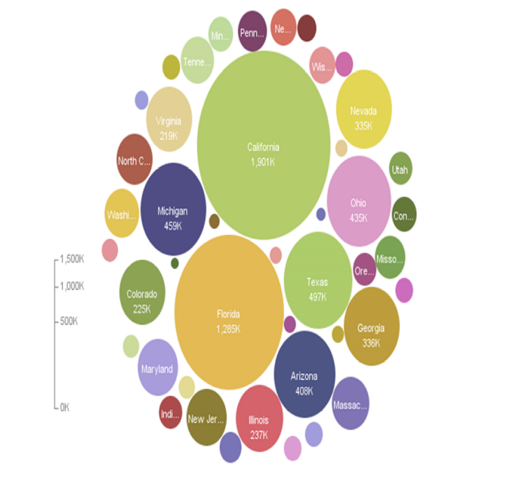
The heat map of foreclosures across United States shown below tells a similar story across the states. Almost all the states, except for a few central and mid-west states, show above average to high foreclosure rates. Most of these states are the ones with high proportion of negative equity, indicating the adverse effect of negative equity on the home ownership across United States.

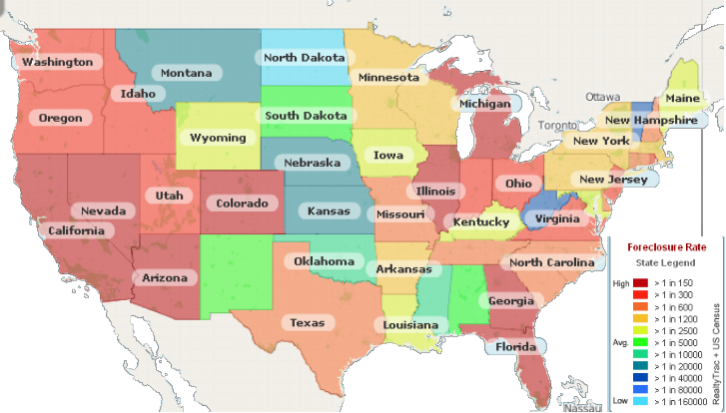
Figure V.1: States by foreclosure rate

A representative sample of states was selected from across the US for detailed analysis. The states were chosen to come up with a diverse sample in terms of geographical region, and impact of housing crisis measured by foreclosure rates and number of negative equity mortgages. The selected states for complete modeling and analysis are Alabama, Arizona, California, Florida, Georgia, Indiana, Kansas, Kentucky, Massachusetts, Michigan, Mississippi, Montana, North Dakota, New Jersey, New York, Ohio, South Dakota, Texas, Vermont, and West Virginia. Out of these twenty states a qualitative assessment of the present housing market situation in five states was also undertaken. Three of these states were chosen from the high foreclosure rate (>1in50) states (Arizona, California and Florida), one from the average foreclosure rate (>1 in 600) states (Texas), and one was a low foreclosure rate (<1 in 20000) state (Montana).

